Downton

Parish Housing Needs Survey

Survey Report

January 2014

Wiltshire Council
County Hall, Bythesea Road, Trowbridge BA14 8JN
Contents Page

Parish summary | 3
Introduction | 3
Aim | 4
Survey distribution and methodology | 4
Key findings | 5
Part 1 – People living in parish | 5
Part 2 – Housing need | 9
Affordability | 13
Summary | 14
Recommendations | 15

1. Parish Summary

• The civil parish of Downton is in the Southern Community Area of Wiltshire. It straddles the Avon valley about 7 miles south of Salisbury and borders the county of Hampshire and is within one mile of the New Forest National Park.
• It has a population of c3000 (2,460 Electoral Register May 2013) comprised of 1,346 households.
• The Parish Council represents the villages of Downton and Charlton All Saints and the hamlet of Standlynch.
• Downton consists of two parts: a village on the east side of the Avon and a medieval new village on the west side. The original village of Downton dates back to the Iron Age with the distinctive wide main street, The Borough, built as part of the new village in the early
thirteenth century.
• The large Conservation Area designated in 1973 contains the important former industrial core to the village, including several mills, which was centred around the river and valley floor comprising flood plain and former water meadow systems. It also contains a significant number of thatched buildings both individually and in groups.
• Downton functions as a Local Service Centre for its surrounding area and has good A-road connectivity to Salisbury and the south coast. The South Wiltshire Core Strategy provides
for balanced growth of both housing and employment with the figure of 190 houses
allocated to be built between 2006 and 2026, of which 50 have already been built.

2. Introduction

In late 2013, Wiltshire Council’s Development Officers discussed carrying out a rural housing needs survey with Downton Parish Council, to establish if there was a proven need for affordable housing in the parish and potentially to use the findings of the survey to inform the parish plan.

Such surveys assist officers in identifying those areas with the greatest housing problems so that scarce financial resources can be put to best use.

Experience has shown that these surveys need to be carried out at regular intervals if the results are to remain relevant in identifying trends.

• The Principal Development Officers are employed by Wiltshire Council’s new housing team
to assist in the delivery of new affordable housing.
• The Principal Development Officers work closely with rural communities, housing associations, local authorities and landowners to meet the affordable housing needs of rural communities.
• The survey is funded by members of the Wiltshire Rural Investment Partnership (WRIP).1

1 The members of WRIP that contribute to the survey funding are Wiltshire Council and seven registered providers of social housing (housing associations) - Aster, GreenSquare, Guinness, Jephson Housing, Raglan Housing, Selwood Housing and Wiltshire Rural Housing Association.
• ‘The Wiltshire Rural Investment Partnership brings together representatives from the economic development, regeneration, spatial planning, new housing and housi ng strategy teams of Wiltshire Council together with Registered Provider [housing association] partners and the Homes and Communities Agency to enable and promote the sustainable delivery
of new build housing in the rural communities of Wiltshire.’2

3. Aim

The aim of carrying out the survey is to investigate the need for affordable housing among the local people (or those who have a need to live in the parish or the locality) of Downton.

• ‘Housing need’ can be defined as the need for an individual or household to obtain housing which is suitable to their circumstances.
• It implies that there are problems or limitations with the household’s current housing
arrangements and that the household is unable to afford or to access suitable
accommodation in the private sector.
• Such problems may be concerned with housing costs, size, location, layout, state of repair, or security of tenure either immediately or in the future.

4. Survey Distribution and Methodology

In order to carry out the housing needs survey, questionnaires were delivered to the Parish
Council for distribution in November 2013.

To encourage a good response, households were given a pre-paid envelope in which to return the completed survey. The council applies the data protection policy to responses, ensuring that all survey responses remain anonymous.

Residents were asked to return the completed surveys in the pre-paid envelopes by 16th December 2013. The forms were recorded and analysed by the Housing Strategy department at Wiltshire Council.

• A total of 1386 questionnaires were distributed to the parish.
• Everyone was asked to complete the first section of the form.
• If a household considered itself in need, or likely to be in need, of affordable housing within the next five years, it was invited to complete the rest of the survey.
• There was a good response rate of 34.3% with 475 replies received.
• The received data refer only to themselves (i.e. to the survey respondents) and should not be taken as indicative of the population of Downton parish.
• Seventeen responses were made online.

2 Para 1.1, ‘Purpose’, Terms of Reference for the Wiltshire Rural Investment Partnership. Full WRIP membership: Wiltshire Council, Aster, Wiltshire Rural Housing Association, Raglan Housing Association, GreenSquare, Guinness, Jephson Housing Association, Selwood Housing, the Homes and Communities Agency, and the Wiltshire Community Land Trust.
5. Key Findings

This report is divided into two parts. The first section looks at existing households in the parish in order to provide a description of the current housing in Downton. This section also describes the levels of new affordable housing, if any, which would be supported by residents of the parish.

The second section examines the households who have declared a need for new housing in Downton. The section begins by describing the overall need for both market and affordable housing in the parish. A financial assessment is then made in order to determine the numbers of households who have a current need for new affordable housing. The results of this financial assessment are summarised in the ‘Recommendations’ of the report (Section 8).

Part One – Households currently living in the parish

The first question asked on the survey was whether the respondents’ home in Downton was their main home. 99.8% of those who replied indicated that their home in this parish is their main home.

The 2011 Census data for Downton indicates that 70.9% of households in the parish were owner-occupying, 10.3% were renting from social landlords, 14.2% were privately renting,
1.3% were living in shared ownership (part owned, part rented) homes, and 3.3% of households were living rent free.3

The chart below shows the tenure of respondents to the survey. The majority (84.4%) of respondents were owner-occupiers, while 7.8% of respondents were living in socially rented properties, 5.9% were renting from a private landlord or letting agency, and 0.4% of respondents were living in shared ownership homes. The remainder were either renting from a relative or friend, living in accommodation tied to their employment, or were living in a tenure described as ‘other’. These results indicate a bias in the survey responses, particularly toward owner-occupiers, and the rest of this section should be read with this in mind.

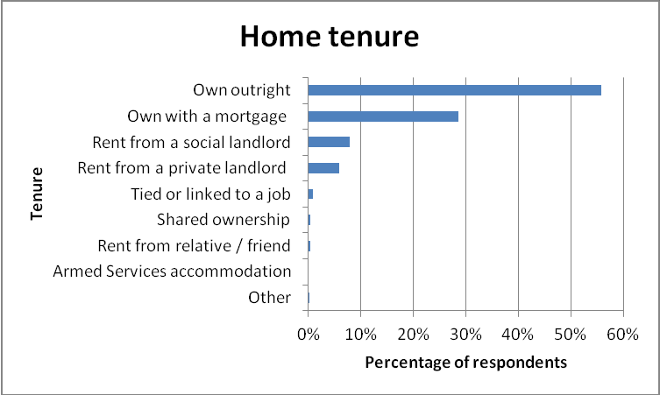

3 http://www.nomisweb.co.uk/

The chart below indicates the length of time that respondents have lived in Downton parish. Nearly half the people who responded to the survey have lived in the parish for more than ten years, which is appropriate for the high levels of owner occupation among survey respondents.

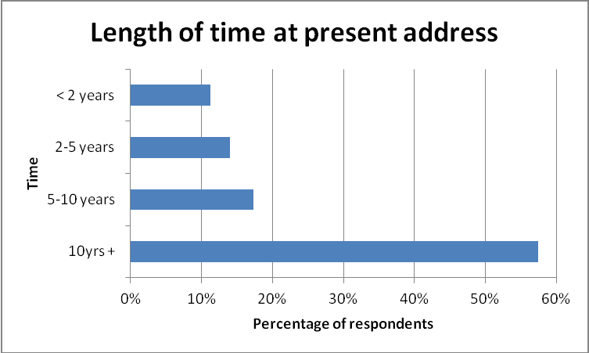

Just over a quarter of the survey respondents (25.8%) lived in homes with four or more bedrooms, while 45.6% of respondents lived in three bedroom homes, 26.9% in two bedroom homes and 1.7% of respondents lived in homes with one bedroom.

Many parishioners responding to the survey were of pensionable age, with 35.8% of survey
respondents’ household members aged 65+:

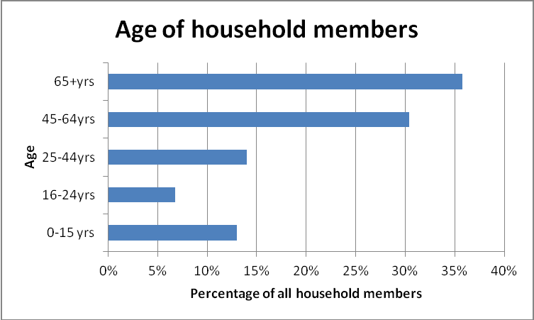

As shown in the chart above, there were also significant numbers of households responding to the survey with members aged 25-64 and with children aged under 16. This indicates a spread of different household types in Downton parish, from older person households with fewer members, to many younger households with children.
The distance travelled to work can also be a good measure of the sustainability of local development, as more people working locally can indicate an ongoing need for local housing. The table below shows how far people in the respondents’ households travelled to work:

Persons in household | Distance to work
 | Up to 2 miles | 2 - 10 miles | 10 - 50 miles | 50 miles + | Total
Person 1 | 43 | 62 | 61 | 24 | 190
Person 2 | 21 | 43 | 38 | 8 | 110
Person 3 | 1 | 10 | 4 | 1 | 16
Person 4 | 1 | 3 | 2 | 0 | 6
Person 5 | 0 | 0 | 0 | 0 | 0
Total | 66 | 118 | 105 | 33 | 322

These results suggest a mixed level of sustainability for new housing development in Downton parish, measured by the survey respondents’ access to employment. Just over half (57.1%) of the respondents’ working household members usually travel less than ten miles to their place of work, which indicates good sources of employment in the local area. Commuter links
through Salisbury also suggest that access to employment over a wider area is viable for many parish residents.

Respondents were also asked whether anyone currently living in their household would need separate accommodation in the parish now or in the near future, to which 6.3% of respondents (28 households) answered ‘yes’. This indicates a sustained, ongoing need for housing in the parish.

Respondents were then asked whether they were in support of new homes being built in the parish and, if so, how many new homes they would support.

A majority of respondents (82.2%) were in support of some new housing in Downton parish. The most popular among the options given on the questionnaire was for between twenty one and forty new homes (29.4% of respondents), while a quarter of respondents (25.1%) felt that the parish required more than forty new homes. 17.8% of respondents were opposed to any new housing in Downton parish:
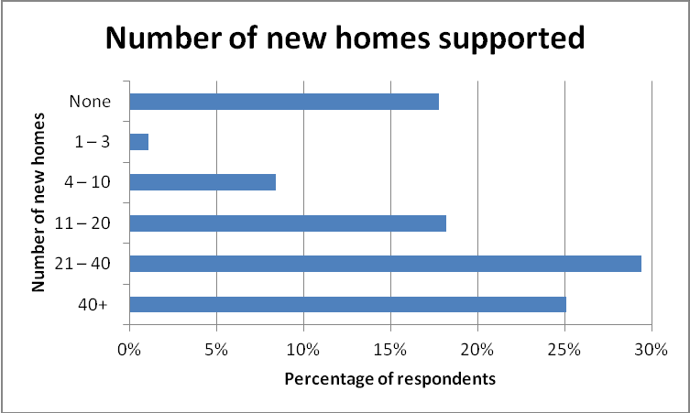
Respondents were asked what types of housing development, if any, they would support.
72.1% supported the development of affordable starter homes for young people, with 46.9%
also supporting the development of older persons’ accommodation. About a third of respondents supported the development of family rental accommodation (36.3%), shared ownership homes (36.9%) and supported accommodation for residents with disabilities (35%).
14.4% of respondents reiterated their opposition to any new housing in the parish:

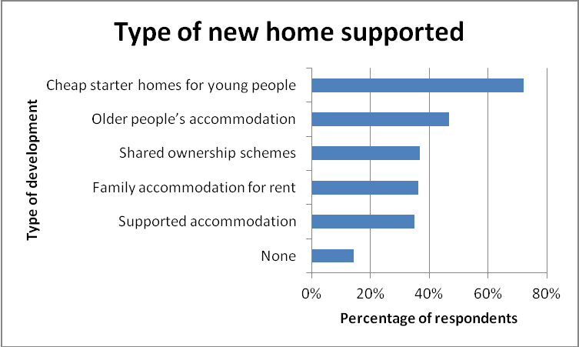
Part two – Households requiring accommodation in the parish

This part of the report looks initially at all the responses to section two of the survey in order to give a broad picture of the need for both market and affordable housing in the parish. A financial assessment is then made in order to describe in more detail the need for specifically affordable housing.

Twenty nine respondents replied to this section of the survey, indicating their need for affordable housing in Downton. Twenty six of these households declared a local connection to Downton, either living or working in the parish, having family members there, or having previously lived there themselves.

The respondents requiring accommodation in the parish were asked what type of tenure they sought. The expressed need was for all types of tenure, with home ownership the most desired. Households could indicate more than one response:

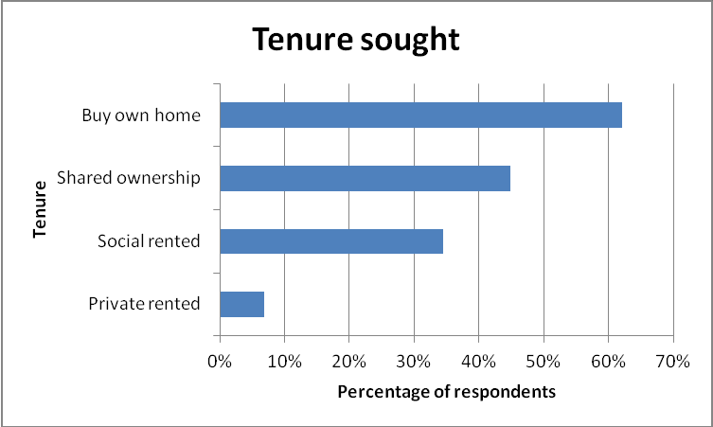

Respondents to this section were also asked what type of housing they required, with the largest majority seeking semi-detached properties, followed by detached homes and bungalows. Full responses are given in the chart below (more than one answer could be given):

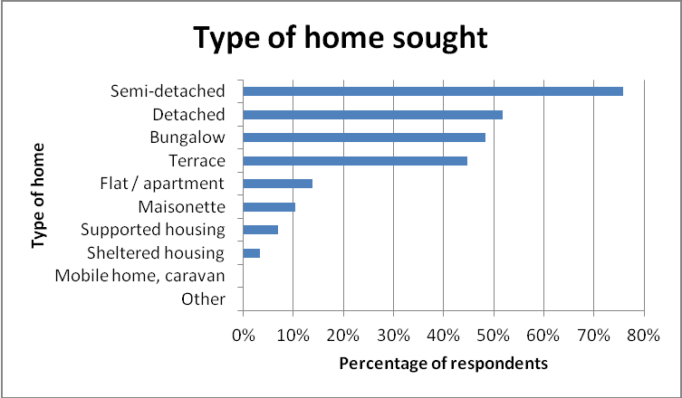

In terms of size, nearly half the respondents (46.4%) expressed a need for properties with two bedrooms. No need was declared for properties with five or more bedrooms:

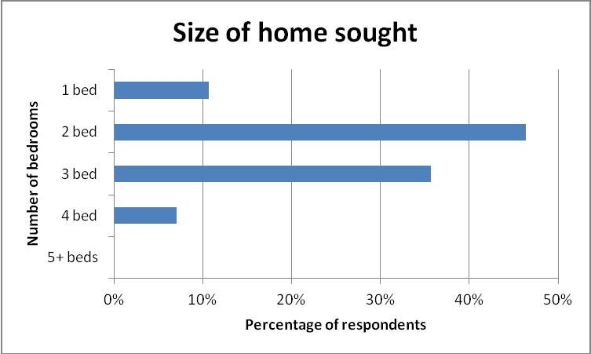

The respondents were then asked if there was a lack of suitable existing housing in Downton parish to meet their needs, to which 93.1% answered ‘yes.’
In order to assess the need for affordable housing in Downton parish, it is necessary to consider the equity, income and savings levels of respondents. The table below presents a summary:

Gross household income, monthly /  annual | No. of house holds | Remaining equity | No. of house holds | Savings | No. of house holds
Under £208 / Under £2,500 | 2 | Nil or n/a | 26 | Nil | 11
£208 - £416 / £2,500 - £4,999 | 1 | £20,000 - £21,499 | 2 | £1 - £2,499 in savings | 5
£417 - £541 / £5,000 - £6,499 | 1 | £100,000 + | 1 | £2,500 - £4,999 in savings | 4
£542 - £666 / £6,500 - £7,999 | 0 |  |  | £5,000 - £9,999 in savings | 2
£667 - £791 / £8,000 - £9,499 | 0 |  |  | £10,000 - £14,999 in savings | 3
£792 - £916 / £9,500 - £10,999 | 1 |  |  | £15,000 - £19,999 in savings | 0
£917 - £1,041 / £11,000 - £12,499 | 3 |  |  | £20,000 - £24,999 in savings | 2
£1,042 - £1,166 / £12,500 - £13,999 | 0 |  |  | £25,000 - £29,999 in savings | 1
£1,167 - £1,291 / £14,000 - £15,499 | 0 |  |  | £30,000 - £39,999 in savings | 0
£1,292 - £1,416 / £15,500 - £16,999 | 2 |  |  | £40,000 - £49,999 in savings | 1
£1,417 - £1,541 / £17,000 - £18,499 | 0 |  |  | £50,000 - £99,999 in savings | 0
£1,542 - £1,666 / £18,500 - £19,999 | 1 |  |  | £200,000 or more in savings | 0
£1,667 - £1,791 / £20,000 - £21,499 | 1
£1,792 - £1,916 / £21,500 - £22,999 | 3
£1,917 - £2,041 / £23,000 - £24,499 | 0
£2,042 - £2,166 / £24,500 - £25,999 | 1
£2,167 - £2,291 / £26,000 - £27,499 | 4
£2,292 - £2,416 / £27,500 - £28,999 | 1
£2,417 - £2,541 / £29,000 - £30,499 | 2
£2,542 - £2,666 / £30,500 - £31,999 | 1
£2,667 - £2,791 / £32,000 - £33,499 | 0
£2,792 - £2,916 / £33,500 - £34,999 | 0
£2,917 - £3,124 / £35,000 - £37,499 | 1
£3,125 - £3,332 / £37,500 - £39,999 | 0
£3,333 - £3,541 / £40,000 - £42,499 | 1
£3,542 - £3,749 / £42,500 - £44,999 | 0
£3,750 - £3,957 / £45,000 - £47,499 | 0
£3,958 - £4,166 / £47,500 - £49,999 | 1
£4,167 - £6,249 / £50,000 - £74,999 | 2
£6,250 - £8,332 / £75,000 - £99,999 | 0
£8,333 - £12,499 / £100,000-  £149,999 | 0

Three of the twenty seven households responding to this section of the survey reported having equity in an existing property. The estimated levels of this were varied, with two households describing the value remaining in their property after mortgage and debts were paid off as between £20,000 and £21,499, and the third as over £100,000. Eleven of the twenty seven households possessed no savings, and a further nine estimated their savings to be under
£5,000. Gross household incomes were varied. Four households declared very low incomes of less than £9,499pa, while two households described higher incomes of £50,000+pa.

Comparing income, savings and equity levels with property prices in Downton suggests that three of the twenty nine households would not require public assistance in order to achieve their required housing. Another household, while expressly seeking to purchase accommodation, rather than rent, lacked the financial resources to afford low-cost home ownership.

The remaining twenty five households would be considered ‘in housing need’ as defined in section 3 of this report. These households inform the recommendations of this survey for new affordable housing in Downton, presented in Section 8.

Of the households meeting the criteria for affordable housing, just over half (52%) were headed by people aged 25-44. One household was aged 16-24, seven aged 45-64 and four households were headed by people aged over 65. Eight households included children aged under 16.
6. Affordability

In order to investigate affordability, further research has been carried out on house prices in the area.

It is possible to estimate the average property prices in the Downton area:4

Bedrooms  1 | Apr 2013 – June 2013  £173,500
2 | £238,700
3 | £292,500
4 | £437,700
5+ | £590,200

Example calculation for a mortgage

Typically, a household making a single application can obtain a mortgage of 3.5 times their annual income, or 3x annual income for joint applications. Households would generally expect to need a deposit of around 15% of the total price.

If an average two-bedroom property sold in Downton cost £238,700 then a household may require £35,805 as a deposit. Annual household income would have to be at least £57,970 for a single applicant or £67,632 for joint applicants. The Annual Survey of Hours and Earnings indicates that the gross annual median income of employed persons in the Salisbury area in
2011 was only £20,226:5

• It would be unlikely that a household would be able to purchase a property in this parish without a large deposit, some equity in an existing property or a substantial income.

• First time buyers would generally struggle to meet the criteria necessary for obtaining their own home.

• In some cases intermediate housing (shared ownership or low cost market housing) would be a suitable option, whilst in other instances affordable rented accommodation would be appropriate.

4 House price estimates from the Mouseprice local area guide to the SP5 postcode area, www.mouseprice.com/area- guide/average-house-price/ . Please note that the SP5 postcode covers a wider area than Downton parish and that there may be significant internal variation in house prices.
5 Annual Survey of Hours and Earnings, 2011, Table 8.7a, Office of National Statistics, http://www.ons.gov.uk . Note that while the mortgage calculation refers to household income, i.e. to the combined income of all persons in the home, the ASHE
figure refers to individual income.

7. Summary

This survey’s recommendations (see Section 8 below) concentrate on those households who are unable to afford accommodation on the open market.

The following indicates the minimum need over the next three years for new affordable housing, based on the responses to the survey. Please note that this report provides a description of the affordable housing need only of those who responded to the survey, and as such may underestimate the total affordable housing needed in the parish.

• In October 2013, there were 175 households on the Wiltshire Council Housing Register seeking affordable accommodation in Downton parish: four of these households are also described in Section 8 of this report as in need of affordable housing. The remaining households on the Register are seeking properties with between one and four bedrooms, and any full assessment of housing need in the parish must take account of the Register.6

• Wiltshire Council and local providers of social housing (housing associations) manage
139 social homes in the parish. These properties represent 10.3% of the total housing in
Downton, which is lower than the Wiltshire affordable housing average of 14.7%.7

• Social housing in Downton had a re-let rate of 2.2% in 2012/13; over this period, only three social homes were re-let in the parish.8

• This low re-let rate suggests that none of the households responding to section two of this survey and in need of affordable accommodation could meet their needs through accessing the existing social housing of the parish.

• While this survey’s recommendations describe the need for affordable housing (see Section 8 below), it should be noted that of the four households responding to the financial questions and deemed not to be in need of or eligible for affordable housing, three described a lack of suitable accommodation in Downton. These households possess the financial capacity to either rent or purchase open-market accommodation and their description of the lack of such suggests a potential need for an open-market or mixed tenure development in the area.

6 Wiltshire Council, Housing Strategy, live tables.
7 Table QS405EW, 2011 Census: Tenure – Households, local authorities in England and Wales.
8 Homes4Wiltshire choice-based lettings records. This figure excludes transfers carried out by individual social landlords within their own stock.
8. Recommendations

This survey’s recommendations concentrate on households unable to afford accommodation
on the open market.

The following indicates the minimum need over the next three years for new affordable housing development in the parish, based on the responses to the survey.

As described in Section 7, the survey is only a quarter of the evidence required to fully assess housing need in the parishes. Wiltshire Council’s Housing Register, the Strategic Housing Market Assessment, and the advice of allocation staff who manage the Register must also be taken into account in fully determining local housing need.

Subsidised rented housing 9

• 4x one bedroom homes (1x single level with care provision; 1x single level)

• 3x three bedroom homes

Shared / Low cost home ownership

• 2x one bedroom homes

• 9x two bedroom homes (1x single level, Lifeline, 24hr support)

• 5x three bedroom homes

• 1x four bedroom home

Sheltered housing for older people

• 1x two bedroom subsidised rented home (single level with care provision).

9 Please note that recommendations for numbers of bedrooms in subsidised rented properties are where possible made in line
with the ‘family size’ criteria implemented as part of the Housing Benefit changes by the 2012 Welfare Reform Act.

