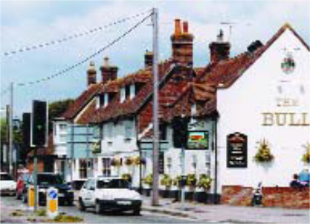Village Design Statement
Downton 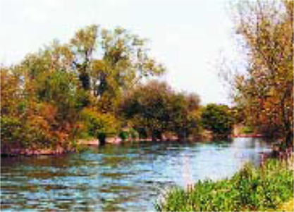

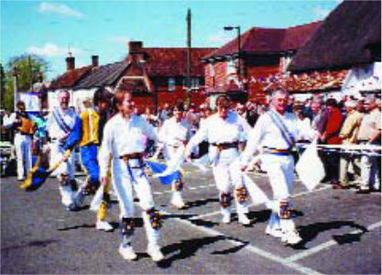
Produced jointly by Downton Parish Council & Salisbury District Council 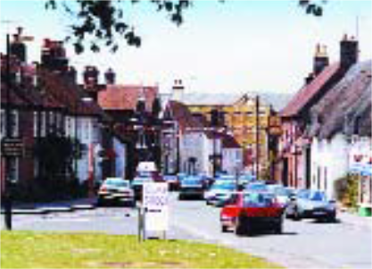

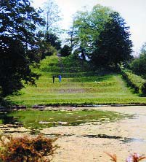

Village Design Statement

Content

- Introduction

- Aims

- How is the Statement to be used

- History

- Landscape Setting

- Settlement Pattern

- Open Spaces and Landscaping

- Buildings and Materials

- Roads and Traffic Management

- Streetscape

- Map

Page 1

Introduction
This village design statement is based on a ‘skeleton’ document prepared by the Downton Society in conjunction with Downton Parish Council. The Downton Society is a village organisation founded in 1973 to stimulate interest in the village and its history, encourage high standards of planning in the village and influence the preservation and improvement of its historic sites and buildings. The ‘skeleton’ document was sent to every organisation in the village and some individuals for their input and comments. A public exhibition was also held where the general public were invited to complete questionnaires and comment on the document. This final document has been prepared by Downton Parish Council in conjunction with Salisbury District Council.

Aims
The aim of this village design statement is to ensure that the design of any future development and any change to existing dwellings in Downton, are based on an understanding both of the village’s past and present character and of its precious environmental setting, so that it can contribute sensitively to the protection and improvement of Downton.

The document therefore aims to offer design advice on the preservation of the present character of the village in the relationships between buildings, open spaces, the treatment of boundaries and the planting of trees, and on the wider perspective of the village as a whole, from surrounding viewpoints.

How is the Statement to be Used?
The Statement has been adopted by Salisbury District Council as supplementary planning guidance and is for the use of all involved in the development process. It will also help inform the wider public on the distinctive characteristics of Downton.

This Statement takes account of policies in the Salisbury District Local Plan which reflect government guidance.

Village Design Statement

Introduction

The Sidings

St Laurence’s Church

The Borough

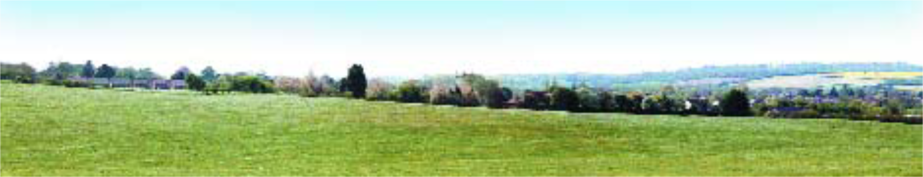

Page 2

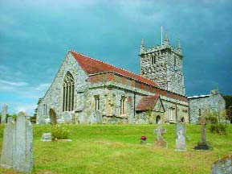History
St Laurence’s Church
Downton is a large village in the Avon Valley approximately 7 miles south of Salisbury, close to the county border with Hampshire. It is an old settlement with the surrounding landscape holding evidence of occupation from the Neolithic and Bronze Age. Named in the Anglo Saxon Charter of 672 AD, the village was known as Dunton, ‘“the village by the hill”.

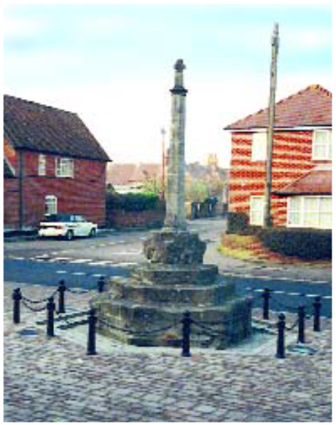By 300AD the Romans had built a Villa and to the Saxons, Downton was an important centre of government. In 638 AD a wooden Christian church was consecrated in the village, probably to be rebuilt in stone in 700AD and as early as 850 AD the Manor House was built to house a Ministry of five clergy. By 1066 Downton was a long established community which gave its name to a ‘Hundred’ stretching from Nunton to Nomansland.
Village Design Statement
History
Memorial Cross
Page 3

In the past employment was mainly connected with agriculture, The Tannery, a bacon factory, corn and paper mills and small cottage industries such as lace making and basket weaving. Today, agriculture is less important. Manufacturing has been sustained through the development of the business park, whilst a number of residents commute to Salisbury, Southampton, Bournemouth and beyond.

Fairs were first recorded in Downton in the 13th century when the Bishop

of Winchester claimed a Thursday market. In 1979 after a break since the First World War the “Cuckoo Fair” was established in its present form. It was called Cuckoo Fair because it was said by neighbouring villages that the cuckoo was released from its pen on Downton’s Spring Fair day. The Fair is now held on the Saturday nearest to May Day each year.

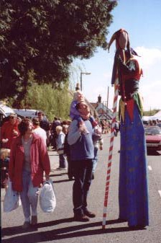The Fair is run on a non-profit charitable basis by volunteers from the village’s various clubs and organisations. The objectives are to encourage art and craft and assist the provision of local leisure time activities in the interest of social welfare. The Fair has over 250 craft and other stands and other attractions including a Maypole, street entertainment
Cuckcoo Fair
and Punch and Judy.

In the centre of the village is a Conservation Area whose character is derived from a number of features, notably: it’s historic layout; the quantity, quality and variety of its historic building; the consistent use of local building materials and

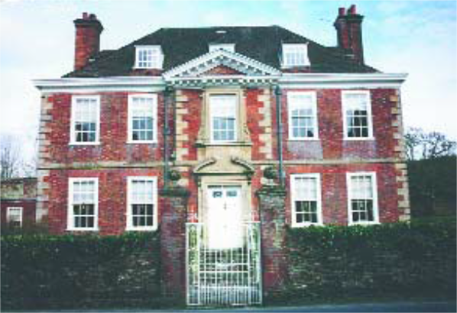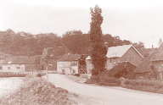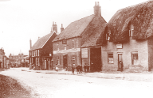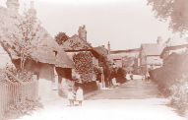vernacular building styles; the landscape setting on the banks of the Avon, open spaces and boundaries. The Conservation Area has two main parts; the older original village around the High Street, St Laurence’s Church, the Manor House and The Moot, and The Borough a ‘new town’ built in the 13th Century on either side of the long Greens which were to be used for markets. An interesting individual feature of some houses along The Borough is the evidence of burgage tenure: numbers set in stone above the doors of properties where some tenants were given the right to vote one of two Downton burgesses to Parliament.
Village Design Statement
Moot House
Page 4
Mill Bridge
High Street
Lode Hill

Wiltshire County Council designated the Conservation Area in 1973 after consultation with Salisbury District Council and Downton Parish Council. Amendments to the boundary were made by the District Council in 1992.

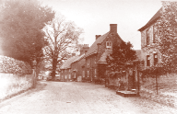The Pictures on the right were taken at the turn of the 20th Century
Barford Lane

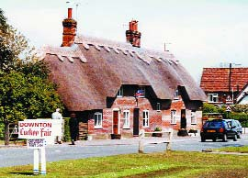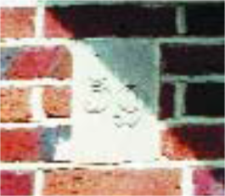

An interesting individual feature of some houses along The Borough is the evidence of burgage tenure:

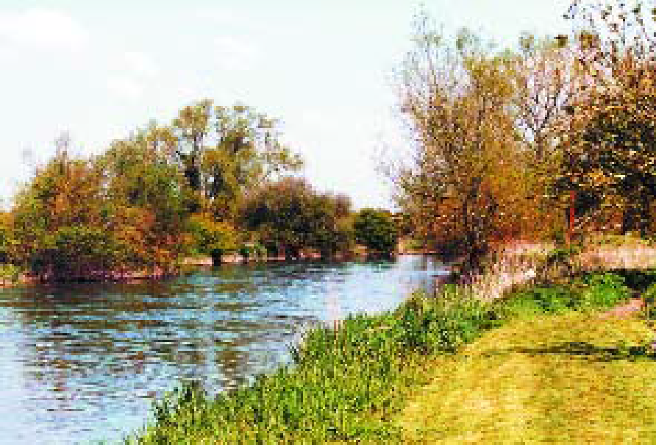Landscape Setting
Village Design Statement
Landscape
Setting
Page 5
The River Avon recognised through its
designation as a Site of Special
Scientific Interest.
Downton sits on the valley floor of the River Avon. Flanked by ancient water meadows, it is enclosed to east and west by a range of hills from which it is very visible as a neat grouping of generally small houses around a few large buildings such as the churches, the tannery building and schools.

Particularly noteworthy is the way it is enveloped by trees and hedges and surrounded by fields giving it a rural rather than urban look. To the west of the village lies the eastern boundary of the Cranborne Chase and West Wiltshire Downs Area of Outstanding Natural Beauty. To the south and south-west, lies the New Forest Heritage Area which is likely to become a National Park.

There are many views of this wider landscape from within the village, including those north and west from the Moot, west from St Laurence’s Church, from the fields north of Hamilton Park, and indeed there are glimpses of downland east and west from along the Borough.

The River Avon and its associated watercourses is an essential landscape feature of Downton, along with the river’s international importance as a wildlife habitat being recognised through its designation as a Site of Special Scientific Interest and a candidate Special Area of Conservation. The River Avon enters the village from the north
through extensive watermeadows. The meadows were originally laid out in the 17th Century to develop dairy farming and the extensive irrigation system is still clearly visible although largely disused. These meadows are essential to the setting of the village and provide good views across and out of the village.

In addition to the agricultural land which surrounds and in places enters the village, there are a number of open spaces within the settlement.
Of particular interest and importance is The Moot, a scheduled Ancient Monument and 18th century landscape garden superimposed on a twelfth century Mott and Bailey Castle. This public garden is an attractive feature, containing many good trees. From the highest points, excellent views are available over the village.

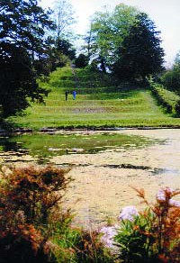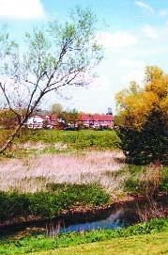The Moot, a scheduled Ancient Monument and 18th century landscape garden

Village Design Statement

Guidelines

- Views into and out of the village should be retained and the opportunity taken to improve or create additional views where possible.

- Any extension of the existing built edge boundaries should maintain the grouping of the village and its setting in the wider landscape, and present a well designed frontage to the countryside.

- The River Avon and its extensive irrigation system should be respected and considered in the design of new development. The opportunity should also be taken to create additional public access to the riverbanks where practicable.

- The conservation and management of existing water features should be encouraged.

Page 6

These meadows are essential to the setting of the village and provide good views across and out of the
village.

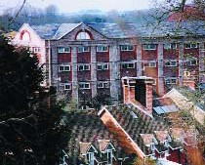The western end of The Borough remains relatively unscathed by modern development, with new limited infill development generally in sympathetic styles and materials. The centre of the Borough has suffered from 20th century rebuild amongst the older listed buildings. Much of this 1960s development is unsympathetic, comprising modern single storey houses set back from the road, large glass windows in shop fronts and the use of artificial or foreign materials. Although these modern developments do detract from the older buildings along The Borough, its overall character is retained.

Village Design Statement

Settlement
Pattern

Guidelines

- New development should respect the existing settlement’s patterns, contribute to the character of the village and, where appropriate, incorporate its own open space.

- The overall roofscape, tree and green space pattern should be retained.

- Urban sprawl is considered inappropriate for Downton. Future development should avoid large single sites grafted onto the outside of the village as has occurred in the past. As such encouragement will be given to new development which is modest in scale, which continues the sense of evolutionary growth and reflects the character and variety of the village.

- Infilling and new developments should follow the line of existing roads and buildings.

Page 7
Rooftop view of Tannery Building

Settlement Pattern
In the east, the original settlement of Downton developed from a Saxon community centred on the enclosed High Street, the Manor House, St Laurence’s Church and The Moot. The High Street’s character is of mainly terraced houses hugging the back of pavements on either side of the street and dominated at the western end by The Tannery building. The ending of the tanning industry in 1999 rendered the building redundant. New proposals for the re-use of this site, including new development provide the opportunity for an enhancement of this part of the village. A 19th century water wheel by the river is an attractive feature of this site.

The Borough, which was developed by Peter des Roches, Bishop of Winchester in the early 13th century remains one of Downton’s most distinctive features and is a near perfect impressive example of medieval town planning. It is characterised by an unusually wide street and still maintains its village greens along most of its length.
The majority of dwellings are terraced or semi-detached and are typically constructed of red brick, although render is also well used. Many are timber framed and have retained their thatched roofs, while others are roofed in slate or tile. Traditionally the housing is set at the back of pavement, without front gardens, producing a tight knit streetscape.
Further post war development of modern houses and bungalows at either end of the village has doubled the size of Downton. At the south-eastern edge of the village is a substantial development of local authority housing dating from the 1950s and 1960s which reflects very few of the original village characteristics. On the north- eastern edge is more modern development, some of which reflects more traditional characteristics such as small dormers, suspended porches and more sympathetic materials. The majority of new development at the western end of the village, to the rear of properties fronting the A338, is standard modern contemporary development of the 1960s and 1970s, which bears little resemblance to the historical village core.

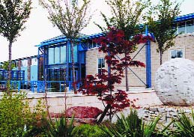The main employment area in Downton today is at the business park at the west end of the village. Set on the northern edge of the village, off the A338 Salisbury Road the area has gradually been developing since the 1950s
Business Park

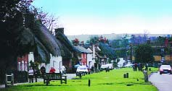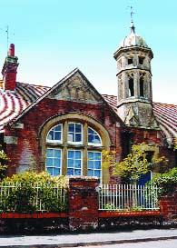

Village Design Statement

- The appropriate redevelopment or re-use of disused buildings or sites within the built-up area of the village is preferred to development on greenfield sites.

- Expansion of the business park should, as far as possible, be screened from the A338 and residential areas in Gravel Close, Long Close and on the Salisbury Road by the planting of indigenous trees and shrubs.

Page 8
The Borough
Downton Primary School

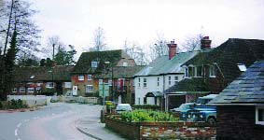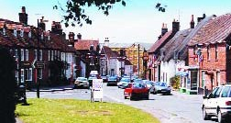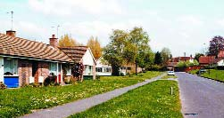and includes manufacturing, warehousing and distribution companies, and service industries. The designs of the different units reflect the changes in construction methods over the years. Some older buildings have been replaced by modern architectural styles.
Mill Bridge
High Street
Moot Lane

The village has a good range of amenities, including churches, schools, doctors, dentists, library, leisure centre, shops, pubs, garages, a bank, a chemist, and an optician. The primary school is a good example of a Board School founded after the Elementary Act of 1870. The nearby Parish of Redlynch helps to sustain many of these amenities.

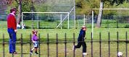

Open Spaces and Landscapes

Village Design Statement

Open Spaces
and Landscape
Guidelines

- The retention of valued open spaces is essential to the overall character of the village. The opportunity should be taken to provide new or improve existing recreation land and facilities, especially in association with new development.

- Landscaping and planting plans should be prepared as part of any new development proposals, and should incorporate locally distinctive and indigenous tree and shrub planting, especially where a development might intrude visually.

- Wherever practicable existing trees and hedgerows, which contribute to the village character, should be preserved and protected.

Page 9
The village contains a mixture of both informal and formal open space.
The village greens of The Borough are themselves a major open feature through the centre of the village.
Mature and growing trees and other vegetation in private gardens, open spaces and within the wider landscape add significantly to the character and ambience of the village. In particular, the mature trees in the garden of Fairfield House and in the Memorial Gardens form a significant feature group in the centre of The Borough.
The Moot offers a peaceful public area for informal use at the eastern end of the village. The gardens provide an ideal spot for walking, picnics, open air plays and concerts.
Formal recreation areas are to be found at the Brian Whitehead Sports Centre, Long Close Cricket ground, the Memorial Gardens and Moot Lane Recreation Ground.
A recent addition to the village is the creation of the Millennium Green.
The Millennium Green is an area of over 10 acres of watermeadow criss-crossed with footpaths, which lies alongside the River Avon at the southern end of Downton. The land was purchased with funding from the Millennium Commission, the Parish Council and local residents. A charitable trust made up on village residents presently manages the green.

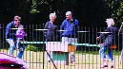

Moot Lane Recreation Ground

Memorial Gardens in the centre of The Borough.

Village Design Statement

4. The conversion of buildings or extensions to existing buildings should retain existing walls, natural boundary features and planting wherever possible.

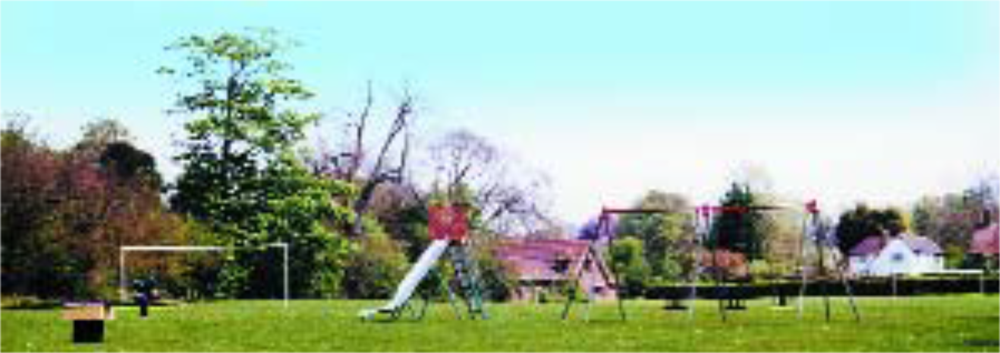

Page 10

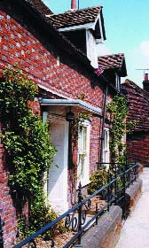Buildings and Materials

Village Design Statement
Buildings & Materials
Guidelines
- New housing should generally be of a simple 2 storey design reflecting the traditional linear style of existing properties in the village, and be based on the scale, particularly roof and eaves height and pattern of existing buildings of quality
- Future development should take account of the variety and individuality of housing design that gives the village its harmonious and mature look. The use of developers’ standard designs, which create uniform suburban development, should be avoided.
- The use of unnatural or alien building materials is to be discouraged, in particular the use of reconstituted stone cladding. Bricks should harmonise with the traditional local red brick.
- Modern contemporary, vernacular building materials and methods may be acceptable where they are designed to blend both in materials and in proportion with surrounding buildings.
- Extensions and alterations to houses should use quality materials and components that match or blend with the existing construction and adjoining properties.

Page 11
In Downton every period from the 14th century is represented. Certain features blend and unify these varied styles. The majority of the dwellings within the Conservation Area are terraced or semi-detached, although most are clearly identifiable as individual homes even where they form a terrace. Most houses are of two storeys and front onto the road serving them, with gardens to the rear.

The village contains over 85 listed buildings, including the Grade 1 listed Church of St Laurence, Moot House and the Manor House. Visible from many points within the village, the church is an important landmark. Other public buildings of note in Downton are the primary school in Gravel Close, the neo-classical Memorial Hall, the Kings Arms and White Horse Public Houses which date from the 15th century, and the Bull Public House. The High Street contains a number of listed shops, some with 19th century shop fronts.

The predominant building material is brick, traditionally of local mellowed red brick, although render is also used. In buildings constructed in the sixties and seventies however, foreign bricks, reconstituted stone and other forms of cladding have been used with unsympathetic results.

The roofs are predominantly tile and slate, although some cottages have retained their thatched roofs. Gabled roofs are common. Roof pitches are usually set at about 45 degrees with a fairly low eaves height. The mix of materials and roof heights contributes towards the variety of the street scene.

Most doors and windows are in keeping with the period of the house’s construction and are

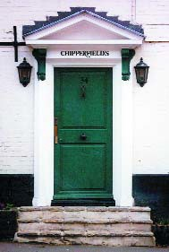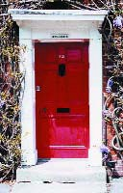

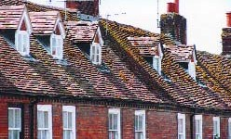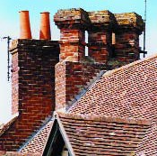predominantly of timber. Sash windows are common. Traditional dormer windows are apparent throughout the village, but they tend to be small and subservient to other features. Doors are traditionally wooden, mainly of solid construction, although simple fanlights are also used. A number of properties have interesting wooden door surrounds and the use of simple suspended porches is common.

Village Design Statement
- Roofs should generally be covered with slates, tiles or thatch and be a minimum of 45 degree pitch, depending on the type of covering to be used. Variety in roof heights, pitches and materials should be encouraged, especially where a number of dwellings are to be built together.
- Gables are preferable to hipped roofs.
- Dormer windows should be small with pitched roofs.

- Chimneys should be incorporated into all new development with the opportunity taken to incorporate interesting designs where appropriate.
- Local characteristics such as cantilevered porches, brick stacks and sash windows are to be encouraged.

- Developers should provide accurate elevations which show new proposals in relation to existing adjoining properties and the wider village context.
- Joinery should generally be of a traditional design and proportional to the property. Lintels should be incorporated as functional and decorative architectural features. UPVC windows and doors should be actively discouraged on front elevations.
- Boundary treatments should use traditional materials appropriate to the locality such as brick walls, railings, low paling fencing or hedges.
- Any development of affordable housing should conform to the general standards of design and materials.

Page 12
Small Dorma Windows
Chimney Detail

Chimneys are usually brick. Interesting examples are found on the cottages along Waterside and the building on the corner of the High Street and Barford Lane. Recent development has in some cases incorporated chimneys, which adds to its character.

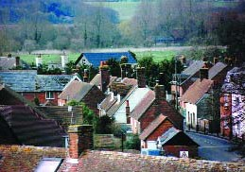Some 20th century development has been unsympathetic in terms of design and use of materials and consequently much of this development does not blend well with the older buildings.
Gabled Roofs

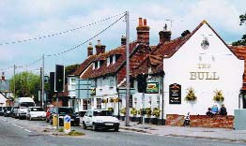Roads and Traffic Management

Village Design Statement
Roads & Traffic Management

Guidelines
- The local highway authority should be encouraged to introduce appropriate measures to minimise additional traffic in Downton, particularly through traffic.

- Developers should avoid cul-de-sacs wherever possible, and seek to form linking roads to encourage social integration and cohesion and reduce the length of car journeys. Pedestrian/cycle links should be provided to existing areas or roads.

- Garaging or off-street parking should be provided for in new development and, where appropriate, be located at the rear of the property.

- The local highway authority should be encouraged to apply flexibility to highway guidelines to avoid changing the rural character of the village by the urbanisation of minor roads and new developments by using inappropriate standards and materials.

- Large visibility splays, obtrusive signs, excessive road markings, concrete curbs and unnecessarily wide pavements should be avoided.

Page 13
A338
The western end of the village is affected by the busy A338 Salisbury-Bournemouth road.
Branching east off this, at the traffic lights, is the B3080 leading through the historic centre of the village towards the New Forest. The effect of through traffic has been a local concern for some time, although a number of recent measures have helped. This includes road narrowing together with traffic priority measures.

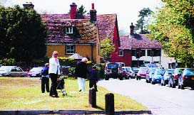The minor roads running off the High Street, The Borough and the A338 are generally unaffected by through traffic, although congestion occurs in places due to narrow roads and on-street parking. A number of the older lanes such as Barford Lane and South Lane have no pavements. In contrast, many of the developments of the last 40 years have wide tarmac pavements with concrete kerbs.
The Borough

Although pedestrian and cycle links exist between certain parts of the village, due to the rivers which flow through Downton, all traffic converges at the pinch points created by the 3 crossing points of the river and its tributaries.

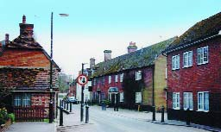Modern developments have tended to be car- dominated, in some cases with prominent garage blocks. Newer developments have to some extent been an advance on this, although there is still scope for further improvement.
Traffic Calming

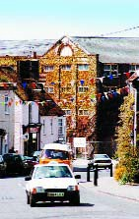Streetscape

Village Design Statement

Streetscape

Guidelines

- The relevant agencies should be encouraged to underground utility services in order to reduce the number of poles and overhead cables.

- The opportunity should be taken when it arises, to replace any existing unsuitable street furniture and signage with a style more appropriate to the character of the village. Similarly, new street furniture in association with new development should be of an appropriate design to suit its rural location.

Page 14
High Street Looking west
Downton possesses a particularly attractive varied streetscape. In The Borough, the road is straight and wide with attractive greens down the centre. Buildings are, on the whole, of a consistent scale, and many older buildings form attractive groups, within a formal planned layout. The High Street is more informal and gradually climbs up towards Lode Hill although buildings remain close knit. Two parts of the village have recently been enhanced with new sympathetic materials and street furniture; the bottom of the High Street and by the White Horse Public House. A traditional red telephone kiosk still remains in the High Street.

Modern street furniture in places detracts from the street scene, including overhead poles and cables, street lighting and wide tarmac pavements. Although it is accepted that some of this is a necessary requirement, there is potential for this to be improved in association with the responsible agencies.

The Borough Cross, a Listed 14th century cross is a feature in the centre of The Borough. Recent enhancement work has improved the setting of this feature, removing parked cars from its immediate setting.

Use of railings and occasional walls contributes towards the streetscene. For example, the railings which front the Memorial Gardens, the bridges over the River Avon and the Millrace, and the cast iron gates of Moot House.

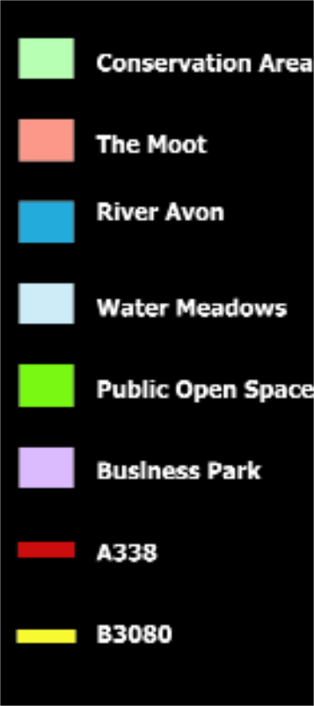Conservation Area

Village Design Statement

Map Key

Page 15
Downton Conservation Area was designated in May 1973 and amended in August 1992. The character of the conservation area is derived from a number of features, notably: it’s historic layout; the quantity, quality and variety of its historic buildings; the consistent use of local building materials and vernacular building styles; the landscape setting on the banks of the Avon, open spaces and boundaries.

The Moot
The Moot is an 8 acre historic garden, listed Grade II* stretching from opposite Moot House down to the eastern bank of the River Avon. The Moot is one of the largest ring work and bailey castles in England and in 1725 the earthworks were overlaid with landscaped gardens for Moot House. This public garden is an attractive feature and contains many good trees. From the highest points there are excellent views across the village to the downland beyond.

Moot House
Moot House is an attractive Grade I listed large detached brick house. It was constructed around 1650 although the interior of the house is largely 20th century, reconstructed after a fire in 1923.

Schools
The Primary School (Grade II listed) is a good unaltered example of a Board School founded after the Elementary Education Act of 1870. It dates from 1895. Downton Secondary School provides education for children up to age 16 from both Downton and neighbouring villages.

Church
The Church of St Laurence is a substantial prominent cruciform church set back off the High Street up a side street called Church Hatch. It is a fine Grade I listed building with a nave dating from the 11th century. The Church is surrounded by an attractive churchyard that contains a listed 14th century limestone cross, 17 listed (Grade II) limestone chest tombs and an attractive late 19th century lychgate with flint and limestone walling and fine carved panels and bargeboards.

River Avon & Water Meadows
The River Avon is an essential landscape feature of the village. It enters Downton from the north through extensive watermeadows which were laid out in the 17th century by Sir Joseph Ashe to develop dairy farming. The extensive irrigation system is still clearly visible although the meadows have now reverted to dry pasture and are largely disused. These meadows are essential to the setting of the village and provide good views across and out of the conservation area.

Public Open Spaces
In addition to the greens running through the centre of the Borough and the extensive watermeadows, there are a number of other undeveloped open spaces within the village. These provide both formal play facilities and informal areas of recreation, and include the Memorial Gardens, Long Close Park (cricket ground), Moot Lane Recreation Ground and The Moot.

The Borough
In the early 13th century Downton was enlarged by Peter des Roches, Bishop of Winchester, into a ‘new town’ by the addition of a long wide street continuing on from the High Street. This is now known as ‘The Borough’ although it was previously called ‘New Market’ and is a near perfect impressive example of medieval town planning. It boasts an unusually wide street and still retains its greens running down the centre. This section of the village assists greatly in giving Downton its unique character.

High Street
The High Street itself contains a mixture of small brick and tiled terraced cottages and larger houses, together a number of shops, some with 19th century shopfronts. At the foot of the High Street stands the old Tannery building which, due to its size, dominates the southern end of the High Street. Although a long established trade in the village, tanning ceased in 1999 and the building is now being converted for residential use. The cottages along Waterside also enhance the character of this part of the village. They are Elizabethan in style with impressive chimneys.

Downton Business Park
The main employment area for Downton is the west end of the village. Set on the northern edge of the village, off the A338 Salisbury Road the area has gradually been developing since the 1950s and includes manufacturing, warehousing and distribution companies, and service industries. The designs of the different units reflect the changes in construction methods over the years. Some older buildings have been replaced by modern architectural styles.

A338
The A338 is the main road linking Bournemouth with Salisbury and beyond. Traffic lights control the junction of the A338 with The Borough.

B3080
Running east from the A338, the B3080 passes through the historic centre of the village towards the New Forest. Recent traffic priority measures at the eastern end of The Borough assist in controlling through traffic.

